Shaping our urban forest approach
Community group submission form
Bass Coast Shire Council is developing an Urban Forest Strategy to plan how we will continue to grow and look after our urban forest. The Strategy will drive improvements to help ensure we grow a healthy, green and resilient urban forest that is well managed, protected and provides maximum benefits to our community.
Visit Engage Bass Coast to find out more about this project.
What is an urban forest?
The urban forest comprises all of the trees and other vegetation in our urban area. It includes street and park trees but also trees and vegetation in backyards, along waterways, in industrial areas, and in conservation areas. Everyone can help grow our urban forest, and enjoy the many benefits trees and shrubs provide.
What areas will the Bass Coast Urban Forest Strategy cover?
The urban areas to be covered are The Gurdies, Pioneer Bay, Grantville, Tenby Point, Corinella, Coronet Bay, Bass, San Remo, Newhaven, Cape Woolamai, Surf Beach, Sunderland Bay, Smiths Beach, Sunset Strip, Wimbledon Heights, Rhyll, Sliverleaves, Cowes, Ventnor, Kilcunda, Dalyston, Wonthaggi, Cape Paterson and Inverloch.
Please note that tree planting in rural areas across Bass Coast is driven by Landcare and Council’s Biolinks program.
Bass Coast Urban Forest today
Our townships have an average of 30% urban forest cover (trees and shrubs) on public land, but only 21% on private land. 30% is considered optimal. So while Council will focus on protecting our existing vegetation cover and improving connectivity by planting along streets and in parks, private land (residential gardens and commercial precincts) has a critical role in nurturing our urban forests.

Input from your community group or organisation
Community groups and organisations like yours play an important role in creating, maintaining and enjoying our urban landscapes. In recognition of this, we would like to hear from your group to understand:
- Your group’s priorities for the urban forest
- How your group would like to be involved in growing and maintaining the urban forest
We’re keen to hear from a wide range of community groups and organisations including Aboriginal organisations, foreshore committees of management, friends of groups, Landcare groups, environment groups, business and tourism networks/associations, community gardening groups, cemetery trusts, school/kindy groups, sporting groups with sports groups, and of course, resident groups. Any groups that have a stake in the urban landscape are invited to write a submission.
The form over page is for community groups (not individuals) to put forward their views and ideas. Please work with your group/organisation to complete the form. Feel free to focus only on the questions most relevant to your group/organisation and email your completed form to Diana Whittington, Diana.Whittington@basscoast.vic.gov.au no later than 5pm Monday 13 June.
Individual members of your group/organisation are also encouraged to contribute to shaping our urban forest by completing the survey on Engage Bass Coast. The survey will be open until 29 May.

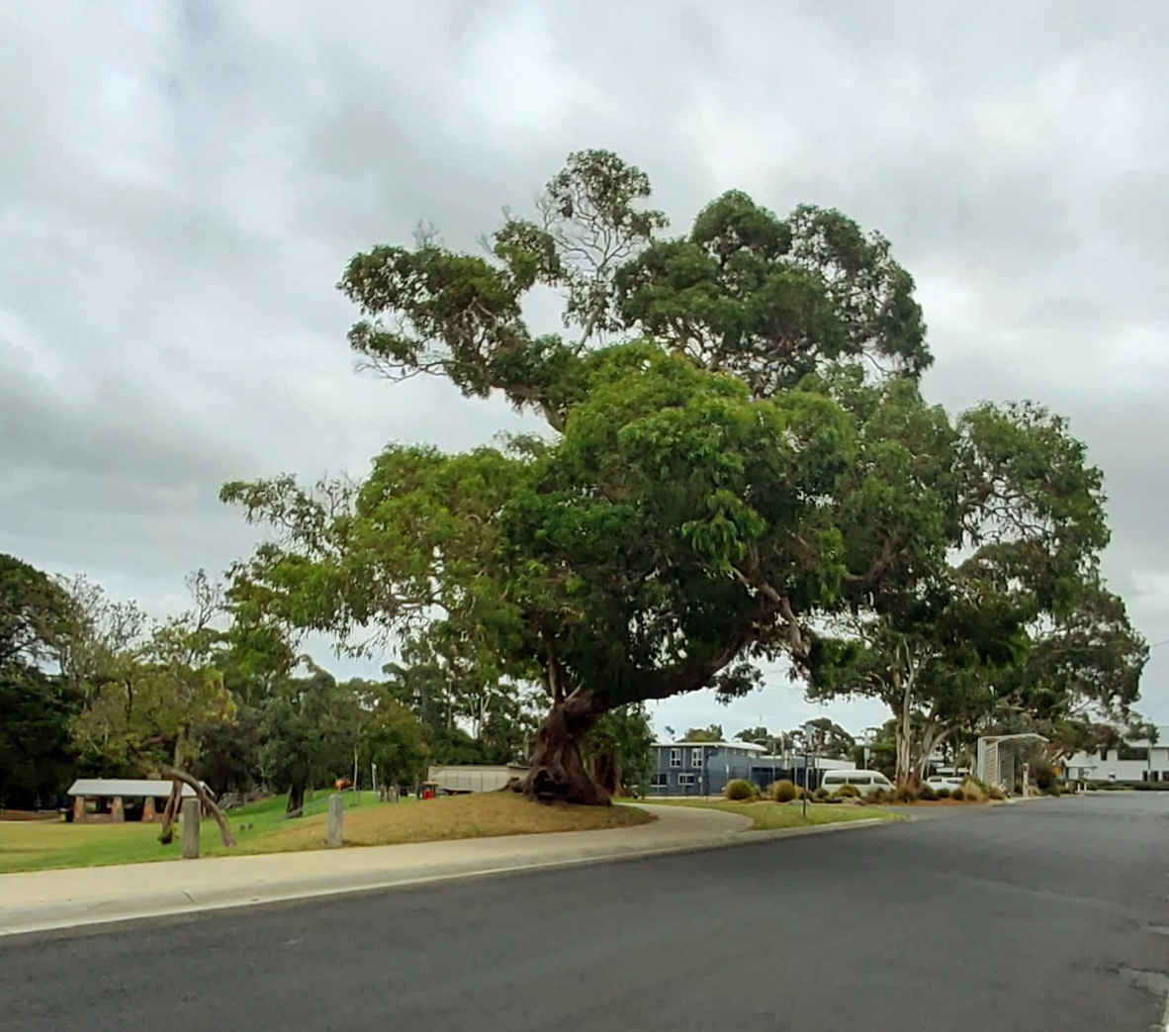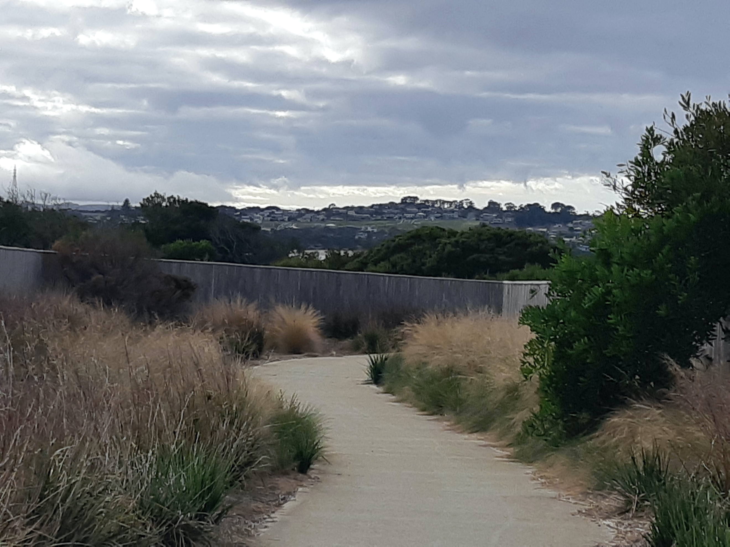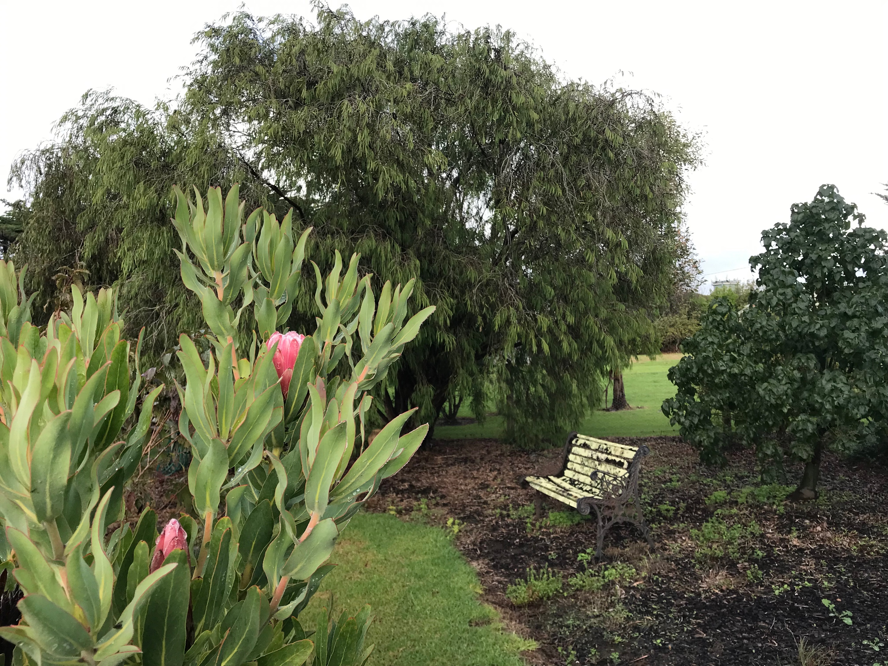

ABOUT YOUR GROUP OR ORGANISATION
Name of group or organisation
Name of representative
Contact details
Email
Phone
What is the purpose of your group/organisation?
In which townships does your group/organisation do most of your work? Please select all that apply
All townships across Bass Coast  Bass  Cape Paterson  Cape Woolamai  Corinella  Coronet Bay  Cowes  Dalyston  Grantville | Inverloch  Kilcunda  Newhaven  Pioneer Bay  Rhyll San Remo  Sliverleaves  Smiths Beach  Sunderland Bay  Sunset Strip  Surf Beach | Tenby Point  The Gurdies  Ventnor  Wimbledon Heights  Wonthaggi  Other (please specify):

YOUR VISION FOR THE URBAN FOREST
Q1. What types of trees does your group/organisation think Bass Coast townships need more of? Please select all that apply
Large landmark trees
Trees that are native to the region
Small trees
Medium sized shade trees
Trees that support local wildlife
Colourful attractive trees
Fruit trees
Trees that are resilient to climate change impacts
Other (please specify):
Comments about the types of trees Bass Coast townships need more of:
500 words maximum please

Q2. What is your group’s vision for the Bass Coast Urban Forest?
500 words maximum please

Q3. According to the experience of your group/organisation, what are the key considerations that need to be addressed in growing and maintaining the Bass Coast urban forest? 1000 words maximum please. Feel free to provide a dot point list of issues.

GETTING RESIDENTS INVOVLED
Q4. We know trees, shrubs and grasses growing in residential gardens play a huge role in the urban forest and supporting local ecology.
How do you think we (Council and community groups/organisations) can best engage and support residents to plant and maintain more greenery in their gardens? 1000 words maximum please. Feel free to provide a dot point list of ideas.

THE WORK OF YOUR GROUP / ORGANISATION
Q5. What is your group/organisation currently doing to help grow or maintain the Bass Coast urban forest? If you group is not currently doing this work, please leave this question blank. 500 words maximum please. Feel free to provide a dot point list of your current initiatives.

Q6. Looking forward, how could your group/organisation support growing and maintaining the urban forest on private land (e.g. residential gardens or business precincts) in the future? If your group does not intend to support the development of the urban forest on private land, please leave this question blank. 800 words maximum please

Q7. Looking forward, how could your group/organisation support growing and maintaining the urban forest on public land into the future? If your group does not intend to support the development of the urban forest on public land, please leave this question blank. 800 words maximum please

Q8. Are there any local collaboration opportunities that could help you scale up your work or work more effectively? 500 words maximum please

Q9. Are there any materials, resources, information that would help your group/organisation effectively scale up or work more effectively? 500 words maximum please

ANYTHING ELSE?
Q10. Is there anything else you’d like to tell us in relation to the Urban Forest? 800 words maximum please

